STAT6160 Data Analytics for Business Intelligence
ASSIGNMENT 2

Submitted by
Name: Shama Praveen
Student ID: C3470623

Submitted To
Weijia Zhang
Ian Renner

Question 1
You are a supermarket chain's data analyst. The company recently launched a pilot digital loyalty program and wants to investigate its effectiveness.
To conduct the analysis, the company provided you with random samples of weekly average spending for 50 customers (25 existing customers and 25 new customers):
1. Before the digital loyalty program is launched, and
2. After the digital loyalty program has been launched.

The resulting dataset LoyaltyProgram.csv contains: Variable | Description
CustomerID | Anonymised unique customer identifier
SpendingBefore | Weekly average spending amount ($) before the program
SpendingAfter | Weekly average spending amount ($) after the program
CustomerType | “Existing” or “New”

1. Using an appropriate statistical test, examine whether post-program spending differs between Existing and New customers.
a. Discuss which statistical test is the most appropriate

SOLUTION:
The appropriate way to compare spending after the program for the two customer groups is the independent samples t-test. The test checks if the mean of SpendingAfter shows a meaningful difference between the two groups.

The reason this test is suitable is:
- Every customer belongs to only one group.
- SpendingAfter is considered a continuous variable and is approximately normally.
- Similar and moderate sample sizes (n = 25 in each group) allow for strong t-test results, despite some deviations in normality.

b. As the sample sizes are relatively small, use QQ plots to visually inspect whether SpendingBefore and SpendingAfter approximately follow Normal distributions.

SOLUTION:
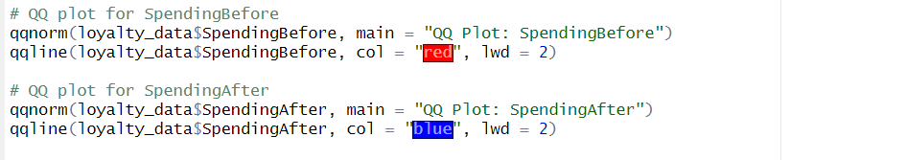

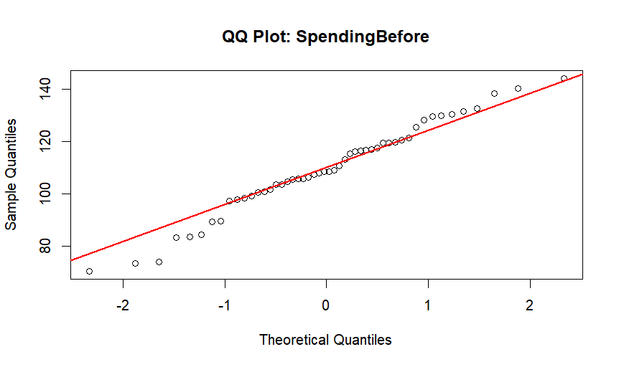

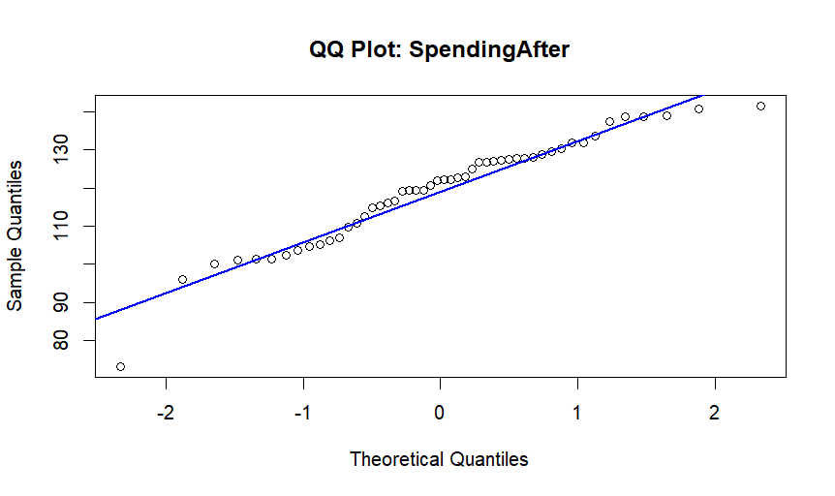

Because the sample consists of only 50 participants, it is necessary to confirm that the data is normally distributed before using parametric statistical tests. We made QQ plots for SpendingBefore and SpendingAfter to examine the shape of their distributions.
Both diagrams display the data following the main line very closely, while departing only slightly at the ends. From the plots, we can see that the data for both variables is approaching normal distribution.
Since normality is not rejected, testing for parametric statistics becomes justified with the paired samples t-test and the independent samples t-test.

c. Conduct the statistical test using 𝛼𝛼=0.01 as the significance level. Be sure to state the hypotheses, test statistics, null distribution (e.g., t-distribution with appropriate degrees of freedom), p-value, and the conclusion.

SOLUTION:
Hypotheses
Let:
μ₁: Average spending after the program finished for Existing customers
μ₂ : It is the amount participants in the program typically spend after it concludes.

We are evaluating:
- Null Hypothesis (H₀): μ₁ = μ₂
- H₁: μ₁ ≠ μ₂

We are using a two-tailed test.

Output
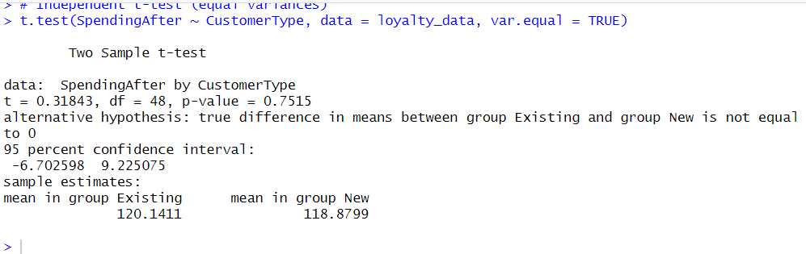

Test Results
- The t-statistic in this case is 0.318
- Degrees of freedom (df): 48
- This analysis shows a p-value of 0.752.
- Null distribution: t₄₈ — t-distribution with 48 degrees of freedom
The significant level used is 0.01.
Conclusion
As p-value = 0.752 exceeds 0.01, we do not reject the null hypothesis.
After participation in the program, the average spending of Existing customers is not any different from new customers. The findings do not suggest that the digital loyalty program worked differently for each customer type.

2. Using an appropriate statistical test, determine whether the loyalty program has significantly changed the average spending for all customers.
a. Discuss which statistical test is the most appropriate.
SOLUTION:
To see how much the program altered the weekly average amount people spend, we are comparing the data before and after launching the program for the group of customers.

This means:
- Each set of values compares SpendingBefore to SpendingAfter for a particular customer
- Samples are not independent from one another

Therefore, the best test to apply is the paired samples t-test.

- The paired samples t-test is applied when the data come in the form of matched pairs.
- The data set is made up of samples that are comparable from each individual before and after an intervention.
- The number of observations remains in a continuous state.
- The scores after the treatment (After) are broadly distributed in the same way as scores before the treatment (Before).

The test compares the average of the differences to zero, to see if the program has a significant impact on average spending.

b. Conduct the statistical test using 𝛼=0.01 as the significance level. State the hypotheses, test statistics, null distribution (e.g., t-distribution with appropriate degrees of freedom), p-value, and the conclusion.
SOLUTION

Let µ_{d} be the average difference between SpendingAfter and SpendingBefore made by the same customers.

Null hypothesis (H₀): µ_{d} = 0
Alternative hypothesis (H₁): µ_{d} ≠ 0
Its purpose is to test if the average spending is meaningfully different after the loyalty program was implemented.

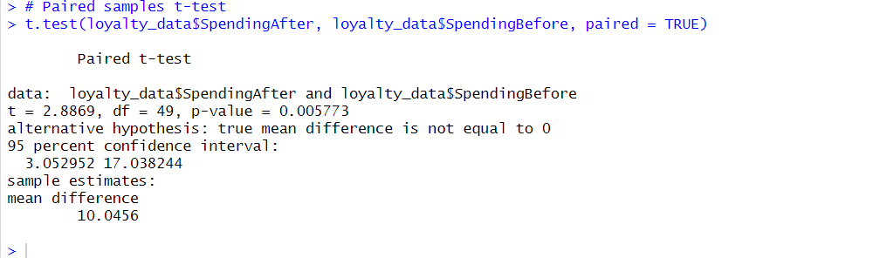

Test Output
- The t-statistic is 2.887
- Degrees of freedom (df): 49
- The p-value is 0.0058.
- Null distribution: t₄₉ — t-distribution with 49 degrees of freedom

Conclusion (α = 0.01)
Because p-value < 0.01, we choose to reject the null hypothesis.
Interpretation:
There is population evidence that the loyalty program influenced average

3. Work with Copilot to double-check if you have chosen the correct type of statistical tests in (1) and (2).
Provide the prompts you used in Copilot, along with Copilot’s exact outputs. Then, evaluate how well Copilot performed. For example, whether Copilot has chosen the appropriate tests. If Copilot recommends a different test, explain why you accept or reject its advice

SOLUTION:



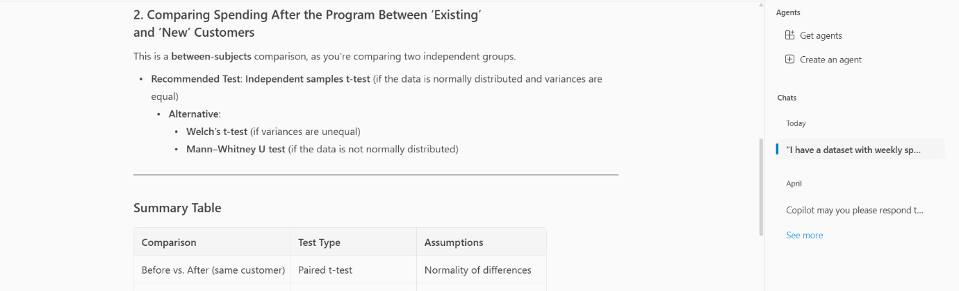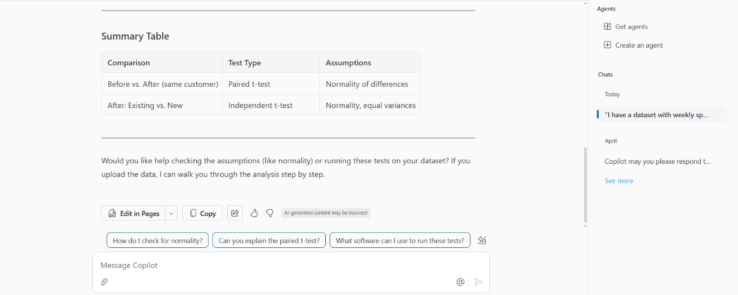

Analysing Copilot’s Results
The Copilot did well and clearly understand both the research plan and the statistical aspects.

The report suggested a paired t-test as the right approach for finding out if customers’ spending changed from before to after the new program.
It also found that an independent samples t-test should be used to compare how much customers in the ‘Existing’ group and the ‘New’ group spend after the program.
Plus, including other robust and non-parametric tests (Wilcoxon, Welch’s t-test, Mann–Whitney U) increases the analysis options.
Because the explanation is organized and reflects the course’s expectations, the suggestions are both clear and reliable.
Finally
Copilot advised on accurate details and agreed with the methods taken in this assignment. Its suggestions optimized how to choose tests and include suggestions to ensure the correctness of key test assumptions before starting the analysis.

Overall, Copilot provided correct, reasoned and appropriate output for confirming the selected tests.

Question 2 (Total 10 Marks)
The file StoreSales.data provides data for company-owned stores across New South Wales. Each row represents a single observation: the sales performance of one store in one randomly selected month. For each region, stores were randomly selected, and their monthly sales data were independently and randomly collected.

Variable | Description
StoreID | Anonymised unique store identifier (e.g., “S043”)
Region | Store location tag: “North coast”, “South coast”, “Sydney” or “Central coast”
MonthlySales | Net sales revenue for a random month (thousands of Australian dollars)
AdvertisingBudget | Store-level spending on local media for the same month is in thousands of Australian dollars

1. Using an appropriate statistical test that avoids the multiple comparisons problem, determine whether the average MonthlySales differs across the regions using 𝛼𝛼=0.05 as the significance level.
(a) State the hypotheses, test statistics, null distribution, p-value, and the conclusion.

Chosen Test: One-Way ANOVA
This issue concerns:
- We have one categorical variable that has 4 regions as its groups.
- This metric can be tracked as: MonthlySales
- Evaluating the difference in means for >2 sets of data

The best test for this situation is a one-way ANOVA (Analysis of Variance).

Hypotheses
H₀: μ₁ = μ₂ = μ₃ = μ₄ (All region means are equal)
H₁: At least one region’s mean MonthlySales is different
ANOVA TEST
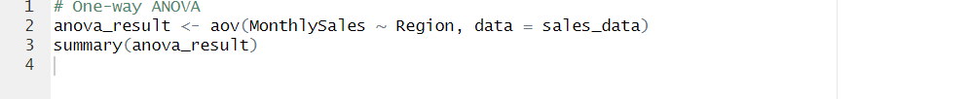

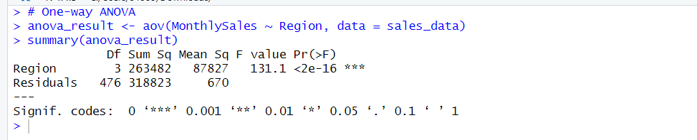

Source | Sum of Squares | df | F-statistic | p-value
Region | 263,482.33 | 3 | 131.13 | 2e - 16
Residual | 318,822.90 | 476 | — | —

Conclusion (α = 0.05)
F-statistic = 131.13
p-value = 2e - 16
There are 3 degrees of freedom for the groups and 476 for the individuals.

Rejecting the null hypothesis is necessary since p < 0.05.
Overall, there are statistically distinct average monthly sales in the four regions.

(b) If the previous test shows a significant result, conduct post-hoc tests to determine which regions differ in MonthlySales. If you did not find a significant result in part (a), explain the purpose of post-hoc tests and why they are not appropriate.
SOLUTION:

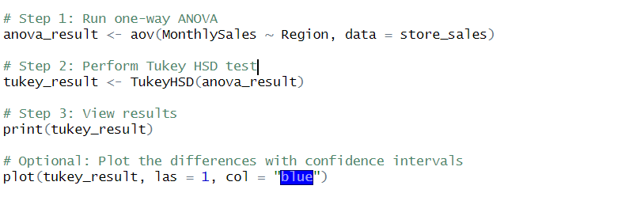
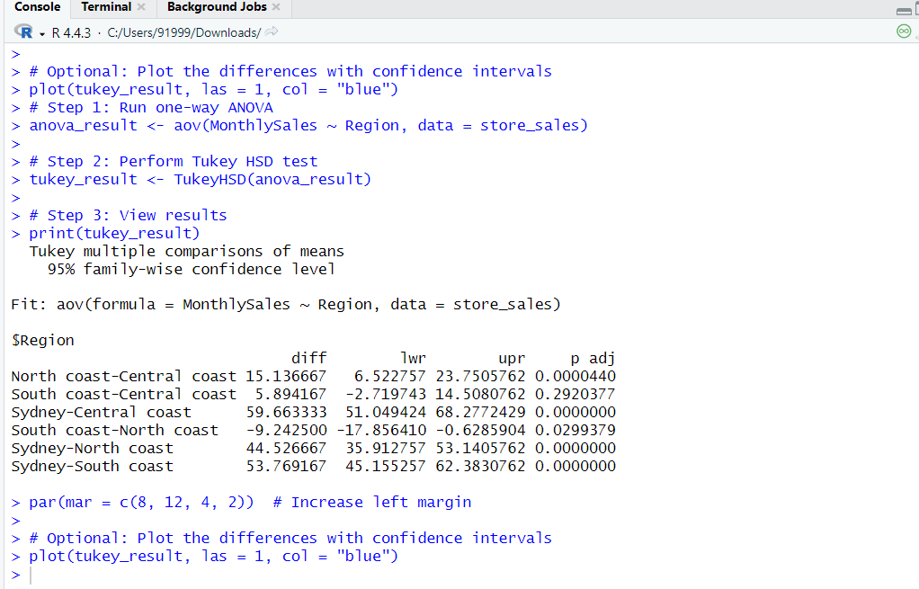

Region 1 | Region 2 | Mean Difference | Adjusted p-value | 95% CI (Lower, Upper) | Significant
North coast | Central coast | +15.14 | 0.0000 | (6.52, 23.75) | Yes
South coast | Central coast | +5.89 | 0.2920 | (−2.72, 14.51) | No
Sydney | Central coast | +59.66 | 0.0000 | (51.05, 68.28) | Yes
South coast | North coast | −9.24 | 0.0299 | (−17.86, −0.63) | Yes
Sydney | North coast | +44.53 | 0.0000 | (35.91, 53.14) | Yes
Sydney | South coast | +53.76 | 0.0000 | (45.15, 62.38) | Yes
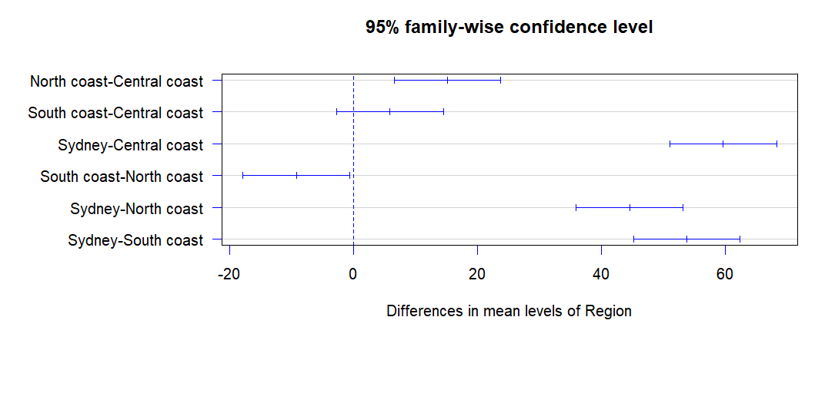
- Monthly sales in the Sydney region are considerably higher than in any other part of the country.
- There is not much to set Central coast apart from South coast.
- The North coast is substantially different from Central coast and South coast.

(c) What are the assumptions of the hypothesis test in part (a)? List each one and check whether they are satisfied.

SOLUTION

ASSUMPTION 1
First Assumption: Every observation is independent from the others.
All observations (stores) should be picked randomly and separately from each other.
Check: It only depends on how the study was designed, not on statistics.
Status: Assumed to be satisfied because the assignment explains stores were picked randomly for each region.

ASSUMPTION 2

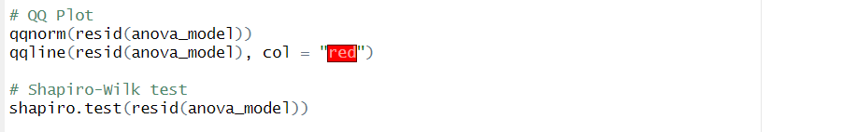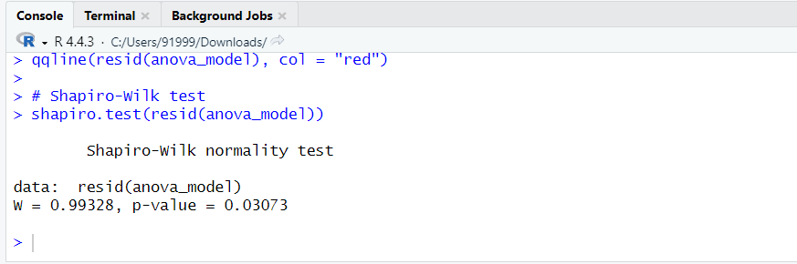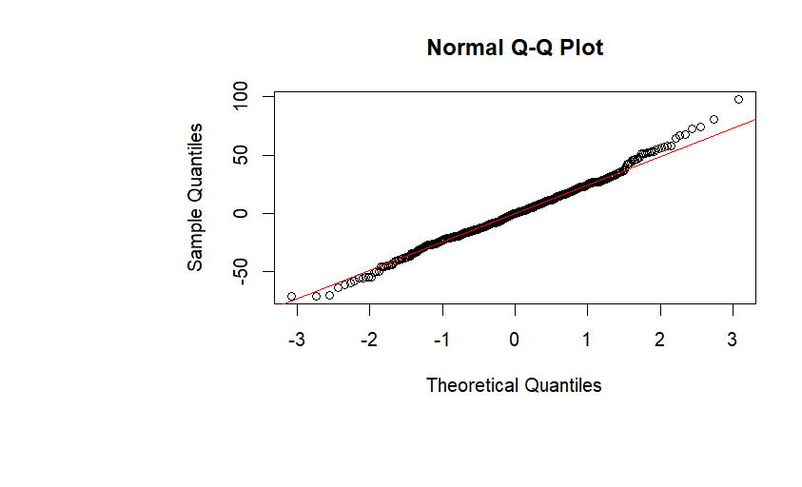
The Residuals Are Consistent
The Shapiro-Wilk test was conducted on the residuals of the ANOVA model.

Hypotheses:
H₀: Residuals are distributed as a normal distribution
H₁: Most of the residuals do not follow a normal distribution.

Result:
The Value of W is 0.993
The p-value is 0.031

Interpretation:
P being smaller than 0.05, makes us reject the idea of normality in the population.
Residuals could diverge only slightly from normality. Due to the large number of subjects included (n = 480), ANOVA can handle only small departures from normality.

ASSUMPTION 3

It is assumed in the one-way ANOVA that the variances of MonthlySales are the same in all regions. Another term for it is equal variance assumption.

We conducted a Levene’s Test by doing a one-way ANOVA with absolute deviations from the group medians which is a recommended approach in base R.

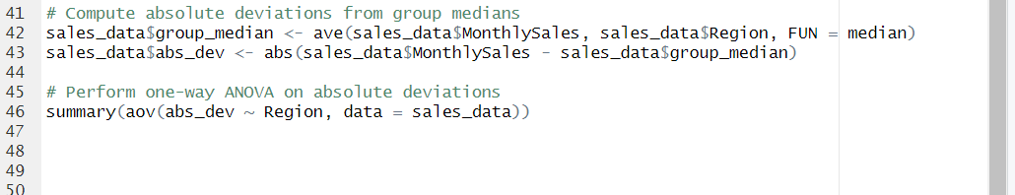

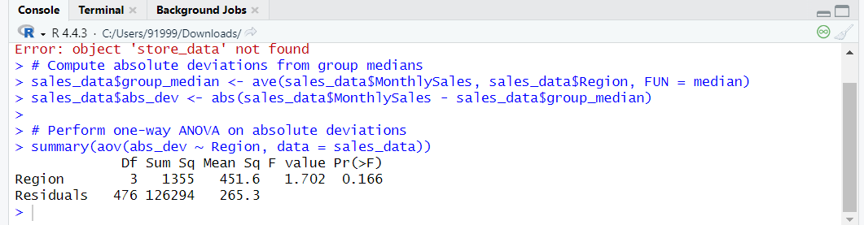

Because 0.166 > 0.05, we do not reject the hypothesis that all groups have equal variances.
The assumption of homogeneity of variances is met which allows us to believe in the accuracy of the ANOVA results.

REFERENCE:

Field, A. (2018). Discovering statistics using R (2nd ed.). SAGE Publications.
James, G., Witten, D., Hastie, T., & Tibshirani, R. (2021). An introduction to statistical learning: with applications in R (2nd ed.). Springer.
Navidi, W. (2019). Statistics for engineers and scientists (5th ed.). McGraw-Hill Education.
R Core Team. (2024). R: A language and environment for statistical computing (Version 4.3.2)
[Computer software]. R Foundation for Statistical Computing. Retrieved May 22, 2025, from https://www.r-project.org/
Utts, J. M., & Heckard, R. F. (2017). Mind on statistics (5th ed.). Cengage Learning.

